Software Development Plan (SDP)

1. Project Overview
Project Name: Order Fulfilment Middleware
Project Description: An automated system to process order data from cyber123.com and create new user accounts on our Moodle platform, Cyber Academy.
Team Members: Paddy McCabe – Software Engineer
Stakeholders: Nigel Morgan – Managing Director, James Brennan – Senior Developer
Project Start Date: TBA
Expected Completion Date: TBA
Version: 3

2. Project Scope
This integration aims to reduce manual account creation overhead, minimise errors, and enhance user experience by ensuring immediate access to purchased documents by the development of an automated integration layer between cyber123.com hosted on the Square Online platform and our organization’s cyber security training platform developed with Moodle, Cyber Academy. This will enable seamless and secure data exchange from cyber123.com to Moodle and then to The Customer.

Inclusions
The project will cover the following key functionalities:
- Development of a webhook-based integration layer to ensure real-time communication from cyber123.com to Cyber Academy and then The Customer.
- Documentation detailing how to develop the middleware, and documentation detailing its individual components.
- Security measures to protect data integrity, confidentiality, and prevent unauthorized access.

Exclusions
This project will not include:
- A graphical user interface (GUI), as the process is fully automated.
- Major modifications to the core functionalities of cyber123.com or Cyber Academy.
- Additional integrations beyond the scope of cyber123.com and Cyber Academy.
- Development of new features outside of the required integration functionalities.

Security Considerations
To ensure the security of the integration process, the following measures will be implemented:
- Webhook Security:
  - HMAC (Hash-based Message Authentication Code) validation to verify webhook authenticity.
  - Source IP validation to ensure webhooks originate from trusted sources.
- Data Protection:
  - Encryption of sensitive data at rest and in transit.
- Infrastructure Security:
  - Firewall restrictions to prevent outside communication from non Square Online sources.
  - Regular security audits, and examination of database and logs added to daily checks.

Constraints
The project will operate under the following constraints
- A strict deadline of TBA with all deliverables expected to be completed within this timeframe.
- Compliance with existing data privacy and security regulations.
- Reliance on a third-party webhook, which may have rate limits and availability restrictions.

Dependencies
The successful completion of this integration depends on:
- Access to appropriate documentation and credentials for cyber123.com and Cyber Academy.
- The availability of necessary infrastructure, such as cloud environments, and databases.
- The stability and reliability of third-party services involved in the integration process.

3. Technical Requirements
Technology Stack: Lamp stack(Alma Linux server environment, Apache Web server, MySql, PHP)
Platform & Environment: Both the application server and database server will be hosted on separate VPS’s on Hetzner Cloud.
Security Considerations: Rate limiting will be implemented as will IP whitelisting, allowing contact from only the necessary IP addresses.
Performance Requirements: While any automated performance is an improvement over manual order fulfilment, thorough testing of the webhook and APIs provided by Square should be performed to ensure reliability.

4. System Architecture & Design
- High-Level Architecture Diagram See Diagrams section in Appendix
- Database Schema Overview See Diagrams section in Appendix
- Third-Party Integrations Square Online e-commerce platform

5. Development Plan
Development Methodology: Waterfall.
Release Plan: Due to the size of the middleware there will be two sprints, one to complete the Middleware that resides on Hetzner Cloud, the next to develop the Moodle Plugin that will listen for the webhook, create user accounts and notify user.
Code Review Process: All commits will be reviewed via pull requests in Gitea.
Version Control: Gitea – development will use feature branches for new updates once the MVP has been deployed into staging environment.

6. Testing Strategy

Due to the size of the application and the timeframe, testing will be manual with PHPUnit tests if time permits. It should be noted that this application is to be viewed as prototypical, to provide us live data from which to refine and improve the application as time goes on.

7. Deployment Strategy
Deployment Environment: As Staging.
CI/CD Pipeline: Gitea for version control, commits to main automatically pushed to production.
Rollback Plan: Daily MySQL backups, Point-in-Time-recovery to be regularly assessed.

8. Maintenance & Support
- Bug Tracking & Issue Management Bugs to be tracked in repository documentation, as well as Dynamics for easy stakeholder access.
- Post-Launch Monitoring App Monitoring should be added to the daily checks.
- User Feedback & Iteration Plan Performance and Effectiveness will be monitored with a view to expanding on functionality in accordance to performance data as it emerges.

9. Risks & Mitigation Plan
- Potential Risks Communication chain breaks in one of the three systems.
- Mitigation Strategies Notifications from Square when an order is purchased, error logs in database, error logs in Cyber Academy.

10. Documentation & References
- Technical Documentation MD files in project repository, meaningful and expansive comments
11. Appendix
11.1 System Diagrams
- 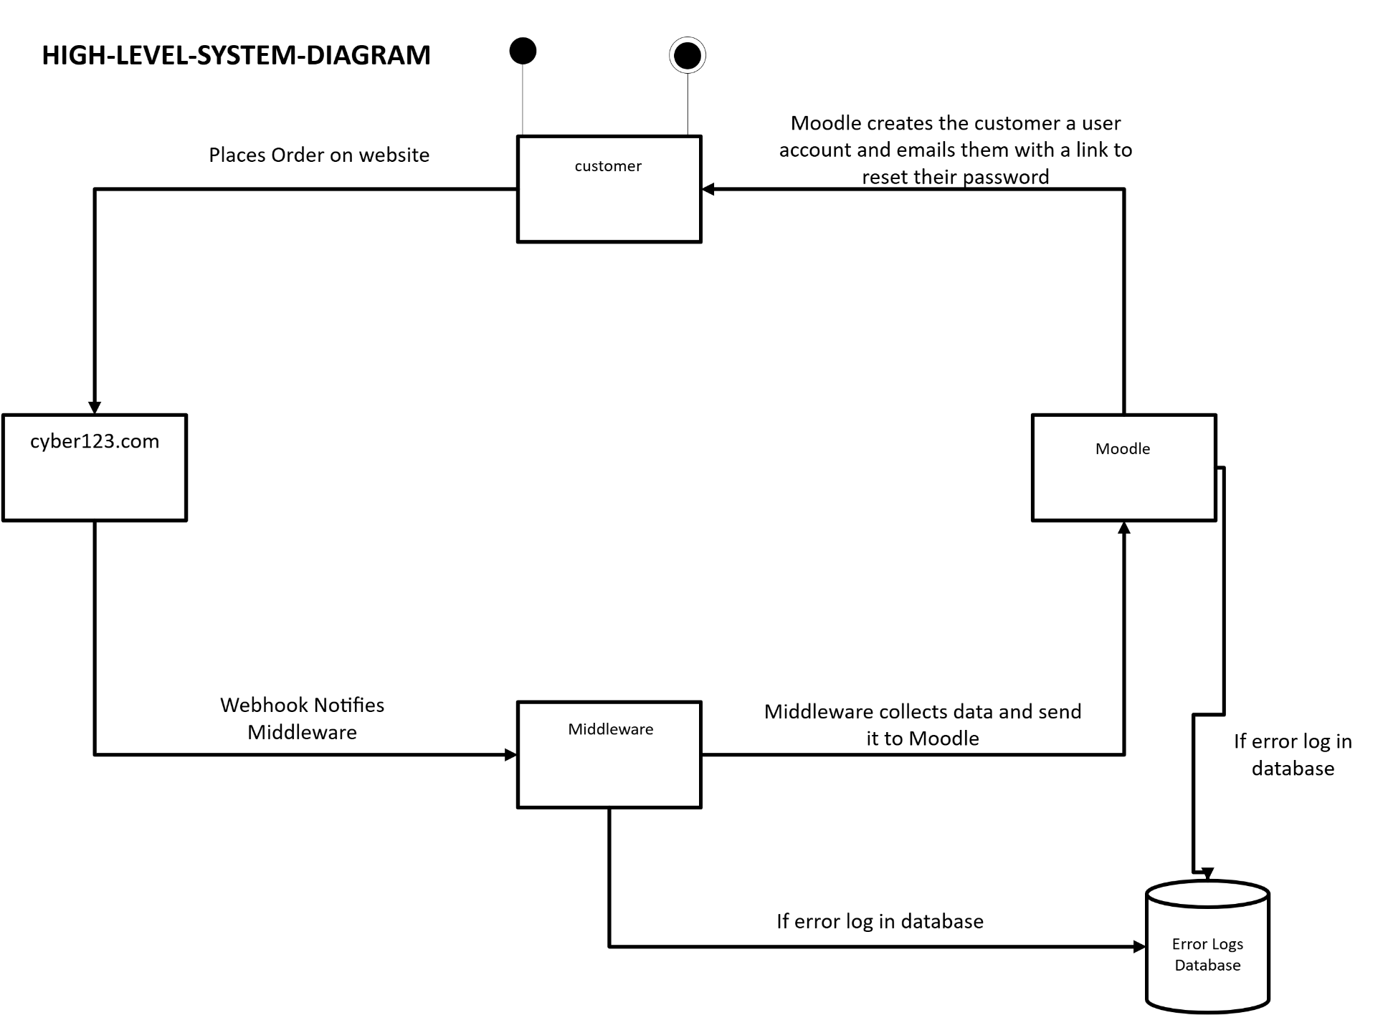
- 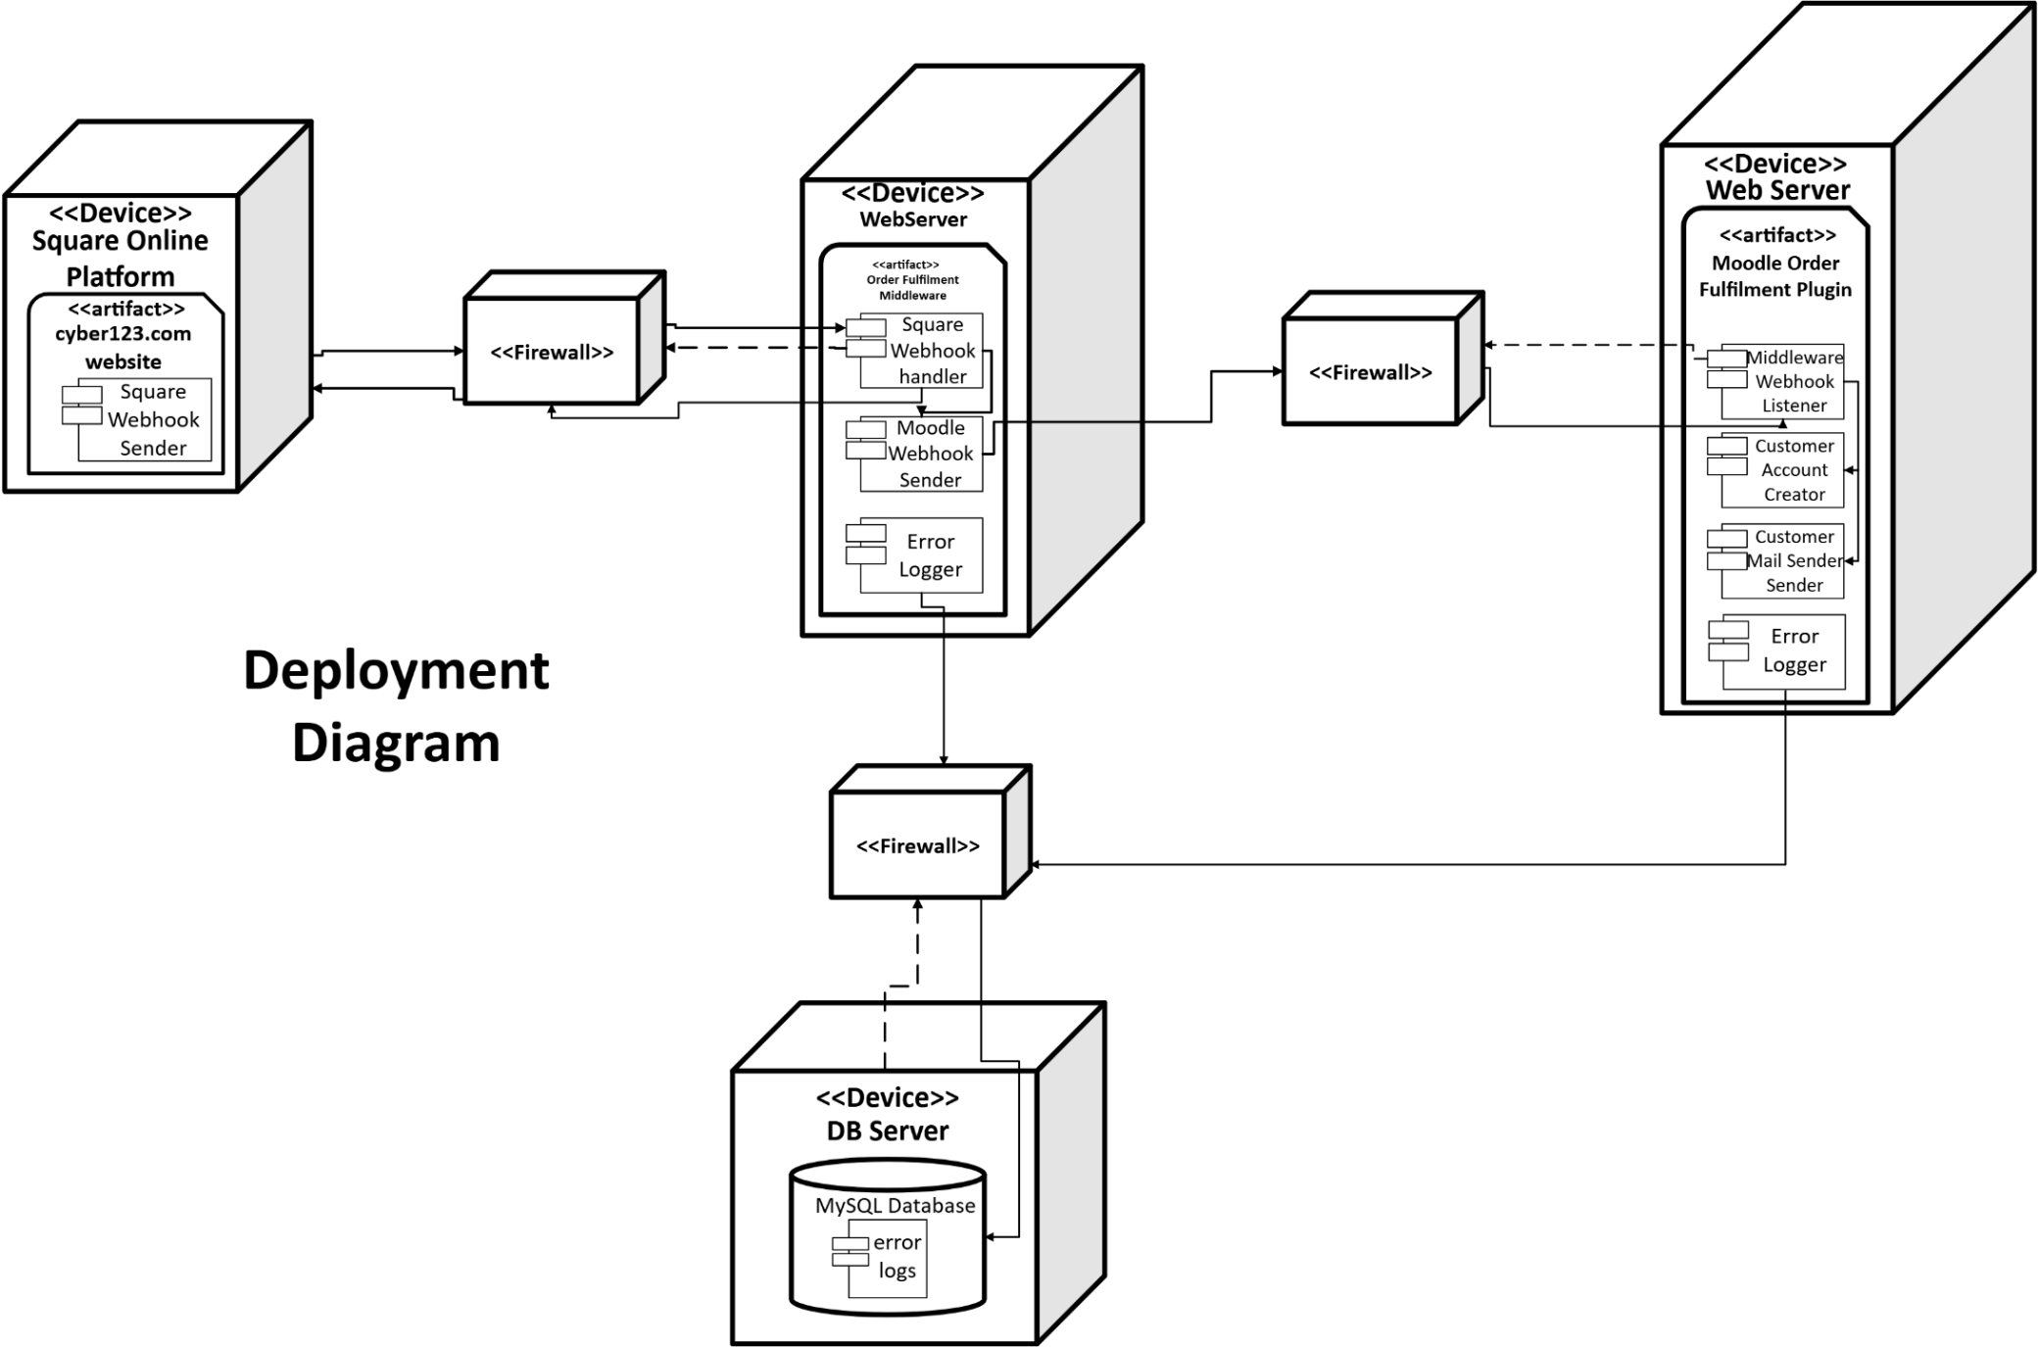

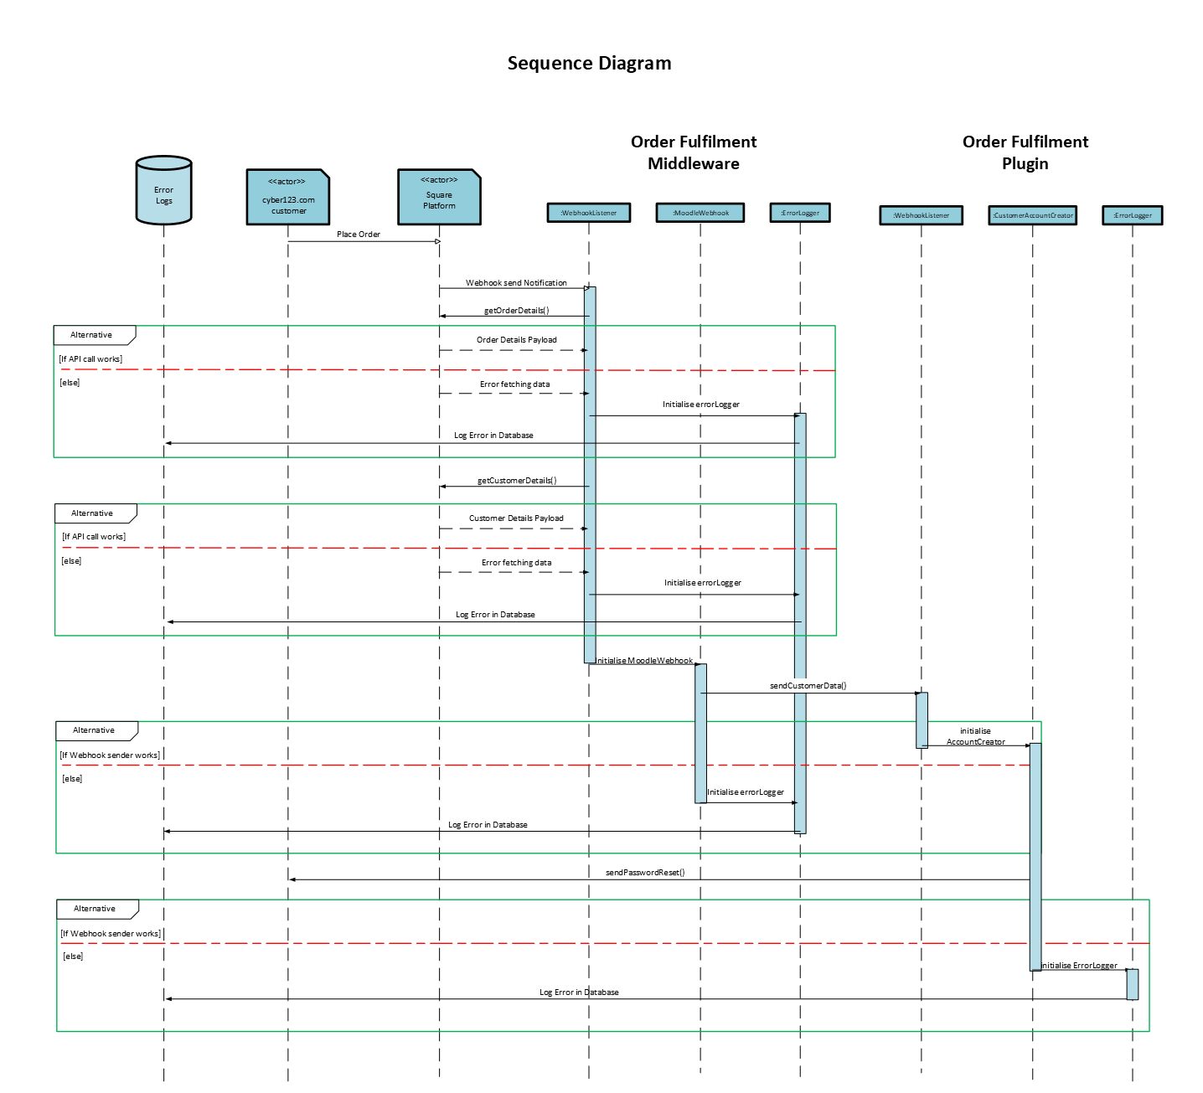
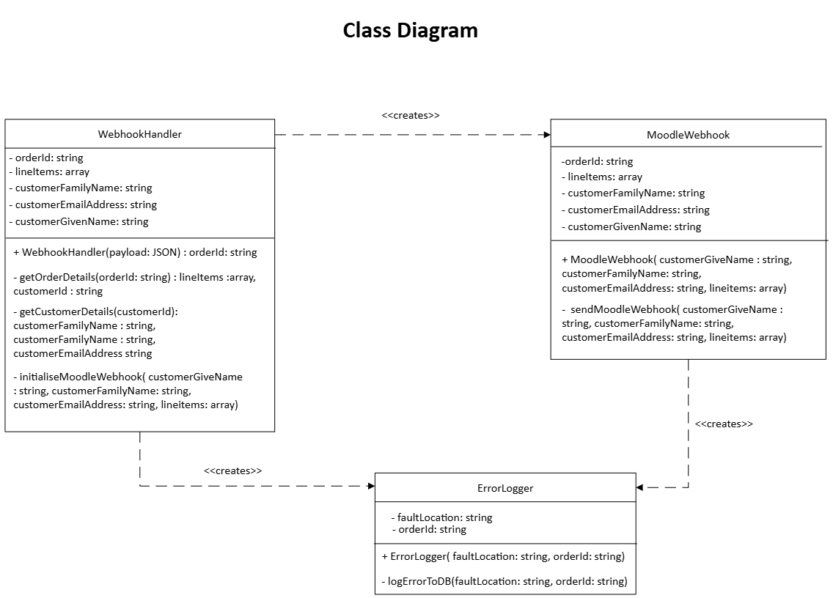
Updated By: Paddy McCabe
Date: 04/03/2025

